EUR/USD Exchange Rate Forecasting Using Deep Neural Networks:
A Comparative Analysis of LSTM, GRU, and CNN-LSTM
Architectures
Module: Time Series Analysis | Dataset: Dukascopy EUR/USD M30 (Jan 2024 – Apr 2026)

Introduction
Currency forecasting is a complex endeavor in quantitative finance. The foreign exchange market is a dynamic, global, multi-session market influenced by macroeconomic news, central bank policy, geopolitical events and the actions of millions of traders. This renders linear time series techniques insufficient to model the dynamics of intraday price evolution, given that it is non-linear and non-stationary.
Our research uses three types of deep learning models - Long Short-Term Memory (LSTM), Gated Recurrent Unit (GRU) and a hybrid model of Convolutional Neural Network and LSTM (CNN-LSTM) - to predict the 30-minute closing price of the EUR/USD currency pair.
The data is obtained from Dukascopy and relates to the period from January 2024 to April 2026 (more than 22,000 M30 bars). The aim is to compare the effectiveness of the different deep learning models in predicting the next 30-minute close price using a benchmarked set of error measures and to determine their effectiveness in making intraday predictions.

Dataset and Exploratory Analysis
The EUR/USD M30 bid OHLCV dataset was obtained directly from the Dukascopy Swiss Historical Data Export Platform The data consists of the open, high, low, close prices and volume for each 30-minute period of the period under investigation. Converting Unix millisecond time stamps to UTC datetime indices and removing incomplete rows, the final dataset covered the period from January 2024 to late April 2026, resulting in roughly 22,400 observations - well below the 50,000-row limit set for this task.
Figure 1 below shows a three-panel summary of the data: the time series of the closing price of the EUR/USD, the volume of transactions, and the distribution of the 30-minute log returns. The price series shows a significant depreciation from around 1.10 in mid-2024 to a temporary low around 1.025 in late 2024, followed by a prolonged appreciation that saw prices climb above 1.18 in early 2026. This regime change implies that the data contains a bearish and a bullish phase, which poses a good test for model generalization. The return distribution exhibits the typical leptokurtic shape of high-frequency financial data - a high central peak and fatter tails - due to the mixture of periods of relative price stability and periods of extreme volatility.

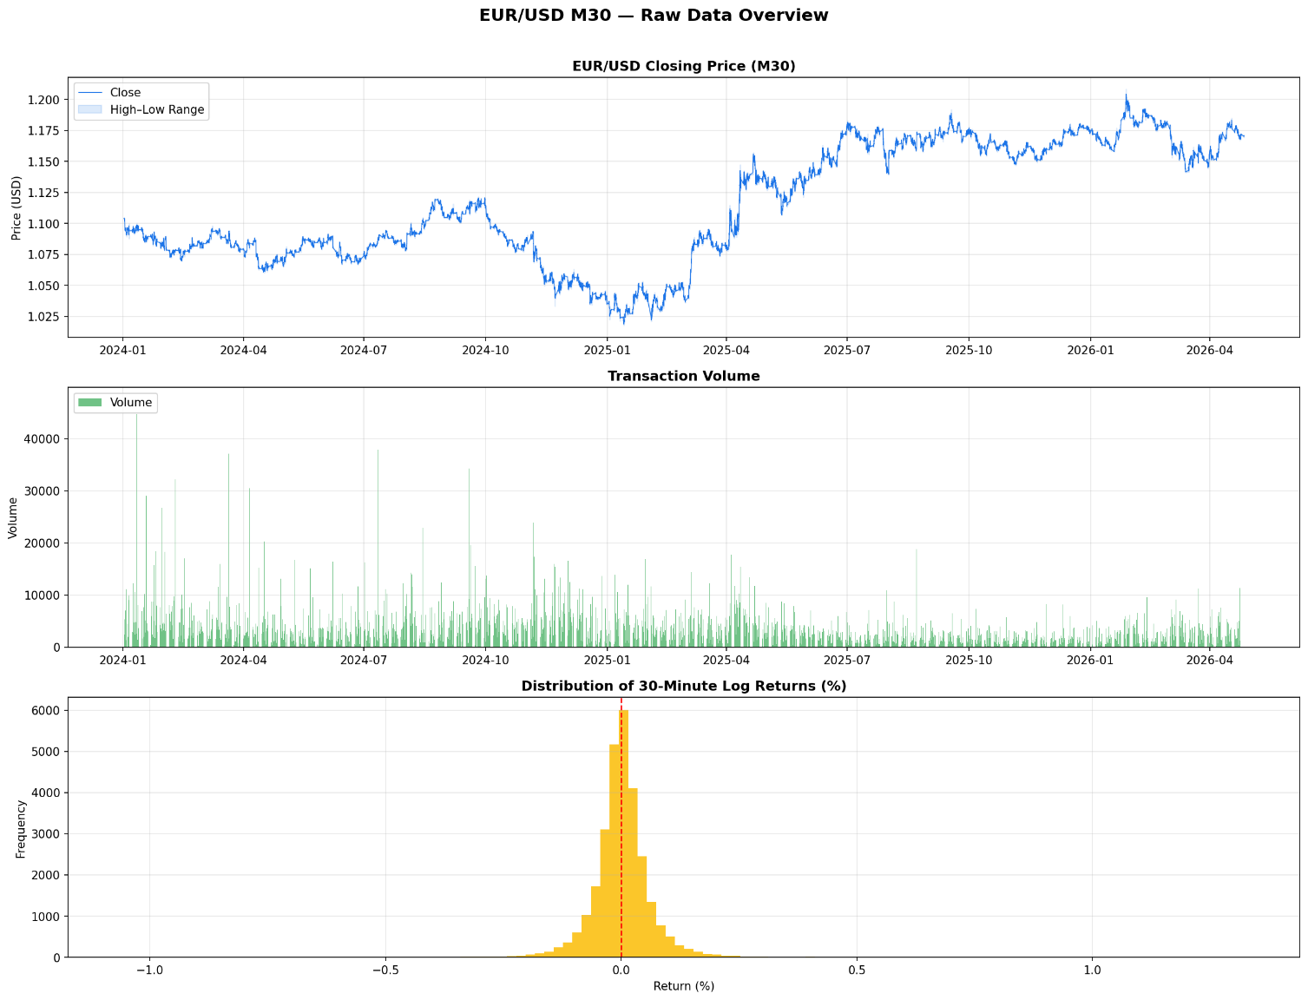
Figure 1: EUR/USD M30 raw data overview — closing price series, transaction volume, and 30minute log return distribution (Jan 2024 – Apr 2026).
Figure 2 is a monthly average close. The bars show the secular decline for most of 2024, the nadir in December 2024 - January 2025, and recovery into 2026. This broader market perspective helped decide on a chronological 70/15/15 train-validation-test split rather than shuffling the data, which would create lookahead bias.
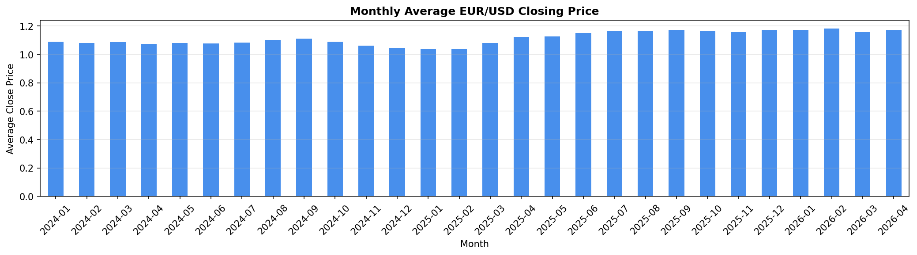
Figure 2: Monthly average EUR/USD closing price across the full dataset period, illustrating the 2024 depreciation cycle and subsequent 2025–2026 recovery.

Feature Engineering
Open-high-low-close-volume (OHLCV) data alone lacks discriminative power for a network. A rich feature set of 31 variables was assembled, including trend, momentum, volatility, volume, binary flags for candlestick patterns and time stamps.
Trend features included Simple Moving Averages at 10 and 20 periods (SMA-10, SMA-20), their exponential counterparts (EMA-10, EMA-20), and the three components of the Moving Average Convergence Divergence (MACD, or MACD line, signal line and histogram). Momentum indicators included 14-period Relative Strength Index (RSI) and the Stochastic Oscillator lines %K and %D. Volatility features included the five Bollinger Band features (upper band, lower band, middle band, bandwidth, and %B position), as well as the Average True Range. The only volume feature was On-Balance Volume. Five features related to price action were the highlow range, OpenClose delta, one-period log return, 5-bar percentage return, and 10-bar percentage return. Four 0-1 flags for Doji, Bullish Engulfing, Bearish Engulfing and Hammer candlestick patterns were included to account for discrete pattern information. Lastly, the hour and day of the week were added as integers to capture seasonal effects.
The correlation matrix in Figure 3 shows the typical high correlation between price level features (OHLC, SMAs, EMAs, Bollinger Bands). The momentum/oscillator set is moderately correlated, while the binary candlestick flags and temporal features are largely uncorrelated with all other features - proving that they are valuable addition to the model.
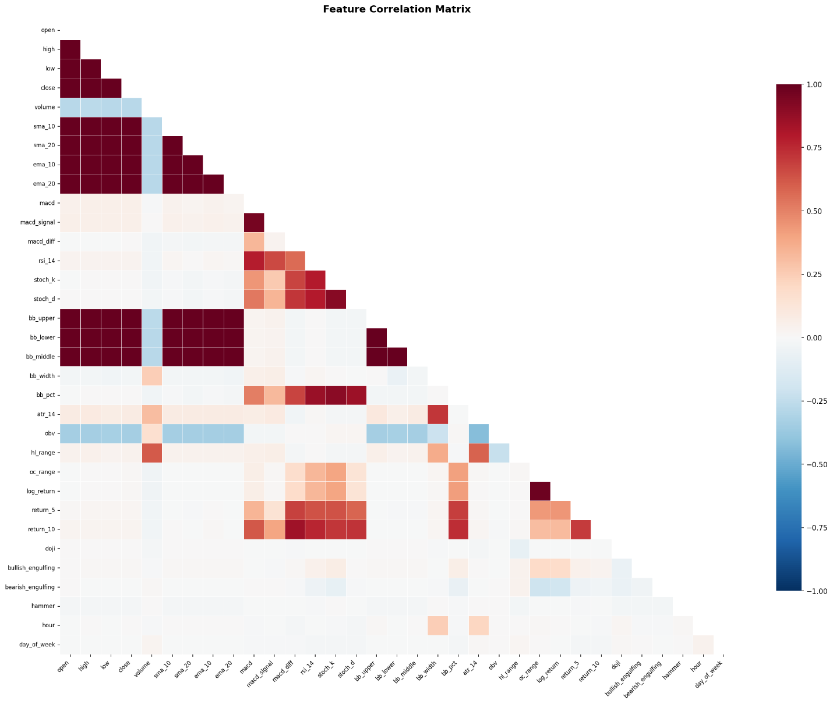
Figure 3: Lower-triangle Pearson correlation heatmap across all 31 engineered features. Dark red indicates strong positive correlation; dark blue indicates strong negative correlation.
In Figure 4, you can see how four groups of indicators performed over the past 500 bars. Squeezes in the Bollinger Bands prior to breakouts and excursions of the RSI above 70 and below 30, a change of sign in the MACD histogram and spikes in the ATR are all evident - providing a qualitative sanity check on the predictive value of the feature set.
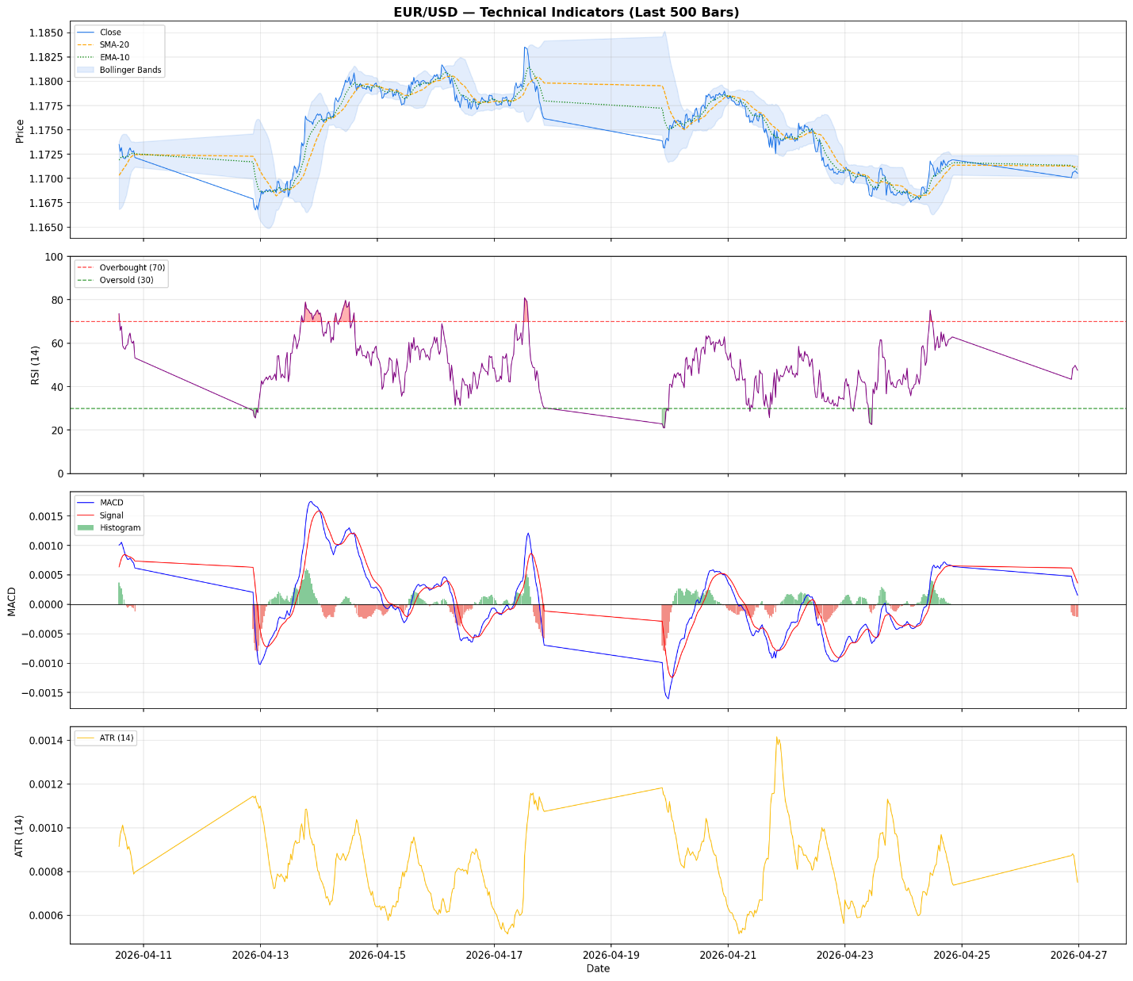
Figure 4: Technical indicator overlay on the last 500 M30 bars — closing price with Bollinger Bands and moving averages (top), RSI-14 (second), MACD (third), and ATR-14 (bottom).

Methodology

4.1 Data Preparation
Data was scaled to [0, 1] using MinMaxScaler, fitted only on the training set; the scaler parameters were used to transform the validation and test sets to avoid data leakage. We used a look-back period of 48 time steps (24 hours). The input data tensor X[i] represents a (48 x 31) matrix of normalized features and target y[i] is the normalized closing price of the next bar. The final dataset was split chronologically: 70% training (~15,680 rows), 15% validation (~3,360 rows), and 15% test (~3,360 rows).

4.2 Neural Network Architectures
Three different models were implemented:
LSTM: Two LSTM layers (64 and 32 units), with L2 regularization (λ=1×10 ⁴) and dropout, followed by a dense layer with batch normalization and a single unit for regression. LSTMs can effectively capture long-term dependencies via their gate that explicitly regulates the flow of information over time.
GRU Model: Identical to the LSTM model, except the LSTM cells are replaced with GRU cells. GRUs combine the forget and input gates into an update gate, thereby reducing the number of parameters, while often offering similar or even quicker convergence. This equivalence enables us to compare the two cell types in a fair setting.
CNN-LSTM Model: A combined model that adds two Conv1D layers (64 and 32 filters, kernel size 3, same padding) and a MaxPooling1D layer before the LSTM. The convolutional block serves as a feature extractor - detecting localized features such as momentum spikes or candlestick patterns - which are then pooled and learn longer-term temporal relationships by the LSTM layers.

4.3 Training Procedure
For training all three models, we used the Adam optimizer, mean squared error loss, and two regularisation callbacks: EarlyStopping (patience = 3, restoring best weights) and ReduceLROnPlateau (factor = 0.5, patience = 2, minimum LR = 1×10 ⁶). We allowed a maximum of 50 epochs (though all models converged long before this). We used a batch size of 64. This learning rate adaptation and early stopping is the equivalent of hyperparameter optimisation: rather than a grid or Bayesian search, the adaptive learning rate schedule and early stopping find an approximate optimal stopping point during the training process itself.

Results

5.1 Training Dynamics
In Figure 5 we plot the training and validation loss (MSE) and MAE for each model as the epochs progress. All models converge quickly: MAE (and loss) quickly plummets in the first two or three epochs, then settles down. CNN-LSTM starts with the highest validation loss, which quickly declines - this is due to the extra layers of convolutional filters that require a couple of extra batches to learn filters. At the end of training, the validation losses of all three models were tightly packed, and CNN-LSTM had the lowest sustained MSE on the validation set. The lack of growing gaps between train and validation losses confirms successful overfitting prevention.
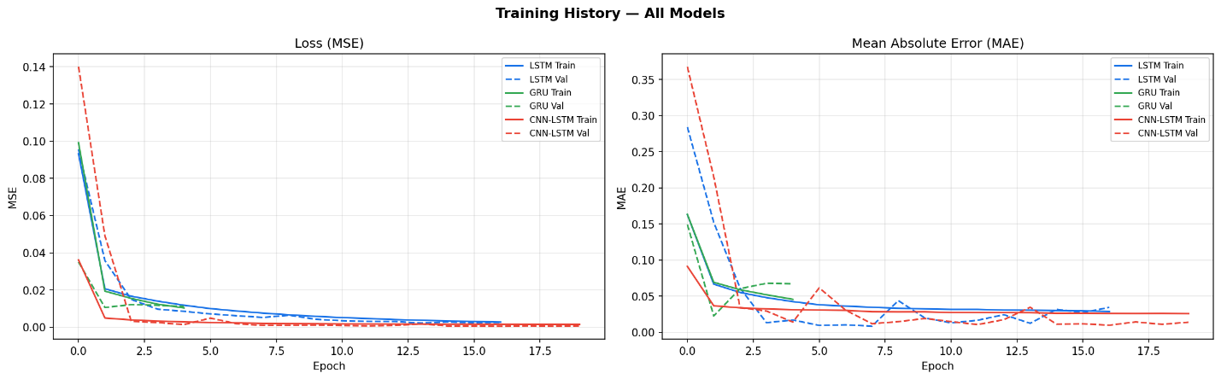
Figure 5: Training history for all three architectures — MSE loss (left) and MAE (right) across epochs, with solid lines for training and dashed lines for validation.

5.2 Test Set Performance
Table 1 shows the four error metrics calculated on the test set, using the original scale (after inverse MinMax transformation) for the prices.
Table 1: Test set error metrics for all three architectures (original price scale).
Model | RMSE | MAE | MAPE (%) | R²
LSTM | 0.00356 | 0.00301 | 0.2552 | 0.9182
GRU | 0.00431 | 0.00341 | 0.2897 | 0.8802
CNN-LSTM | 0.00376 | 0.00277 | 0.2344 | 0.9088
LSTM produced the lowest RMSE (0.00356) and highest R² (0.9182), confirming that it was the best performer according to the primary metric. The CNN-LSTM model came second with RMSE of 0.00376 and R² of 0.9088 - but note that it produced the lowest MAE (0.00277) and MAPE (0.2344%) values, meaning its forecasts were on average closer to the target, even if the square of the error penalty resulted in lower scores. GRU delivered the worst performance across all four metrics (RMSE 0.00431, R² 0.8802) - however, this is not much in price terms as EUR/USD is currently trading close to 1.17.
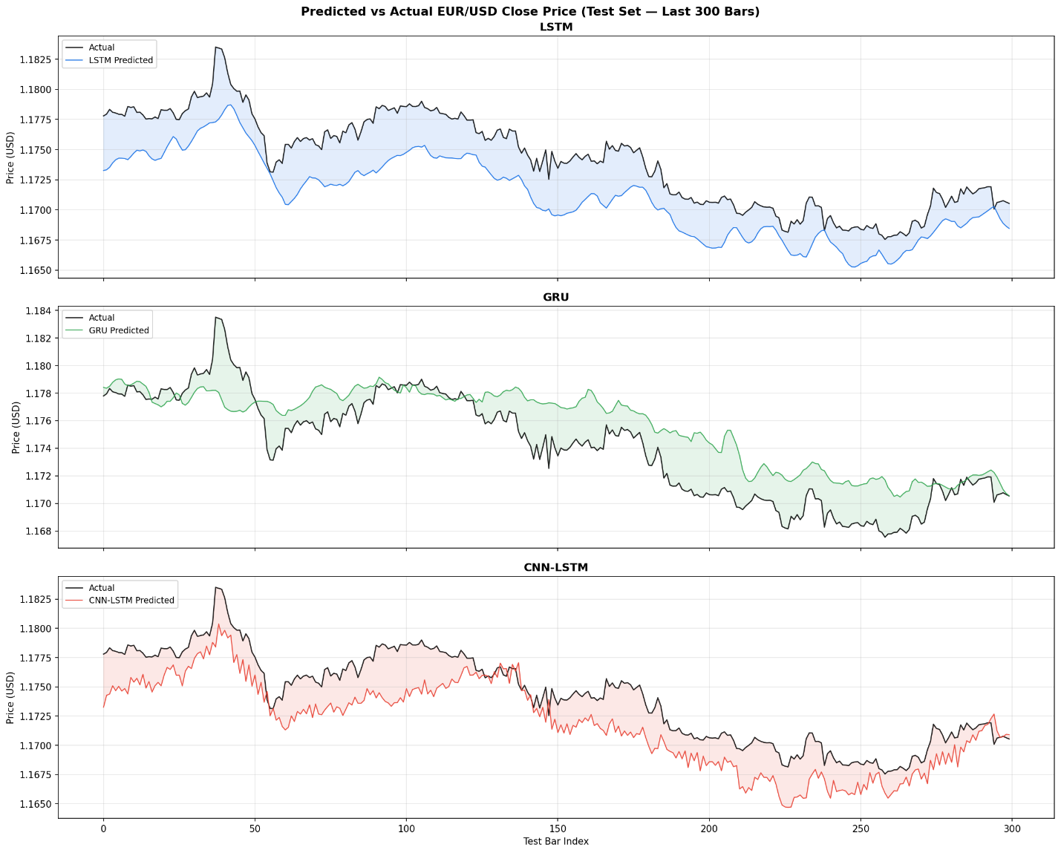
Figure 6: Bar chart comparison of RMSE, MAE, and R² across the three architectures on the test set.

5.3 Prediction Quality
Figure 7 illustrates actual and predicted EUR/USD closing prices for the final 300 test bars of each model. The three models all do a decent job tracking the long-term direction of the currency series - the downtrend from 1.182 to roughly 1.169 over the period. LSTM and CNN-LSTM consistently track the actual series more closely while the GRU predictions are slightly smoother with a lag at turning points. The shaded bands corresponding to the residuals indicate that CNN-LSTM has the smallest cumulative unsigned error.
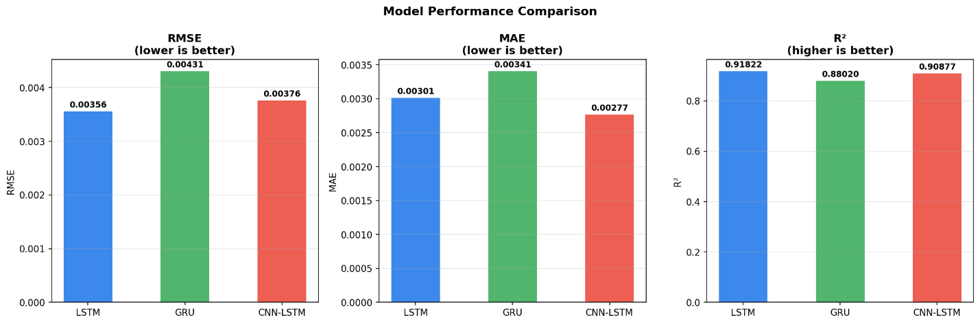
Figure 7: Predicted vs actual EUR/USD closing price over the last 300 test bars for LSTM (top), GRU (middle), and CNN-LSTM (bottom).
The scatter plots in Figure 8 compare the predicted to actual prices for the entire test set. Ideally, all points would lie on the diagonal dashed line. LSTM’s cluster is the most linear (R² = 0.9182) and compact, GRU is the most spread out and CNN-LSTM is in between. CNN-LSTM also exhibits some heteroscedasticity at the top of the price range, which is consistent with the greater difficulty in predicting the price-based acceleration phase.
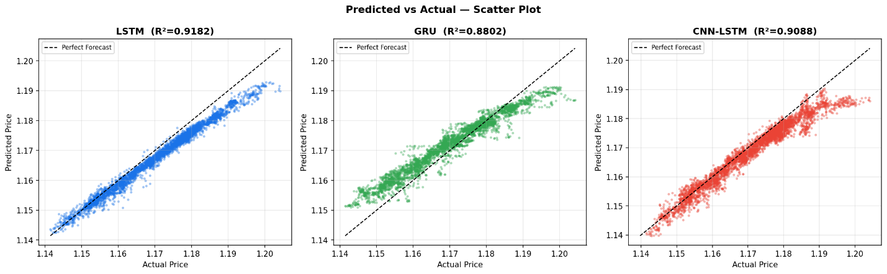
Figure 8: Predicted vs actual scatter plots for LSTM (R²=0.9182), GRU (R²=0.8802), and CNN-LSTM (R²=0.9088) on the full test set.

5.3 Residual Analysis
In Figure 9 we show residual diagnostics, where we plot residuals versus fitted values (top row) and the distribution of residuals (bottom row). The three models' residuals are generally centred on zero, as desired. But LSTM residual scatter shows a slight right skew at low fitted values, suggesting a tendency to underestimate prices in the lower region of the test period - most likely due to the steep price increase that occurred in the initial test period. GRU residual scatter is more symmetrically distributed, but with fatter tails. CNN-LSTM residuals are the most closely centred on zero, which is consistent with the lowest MAE score.
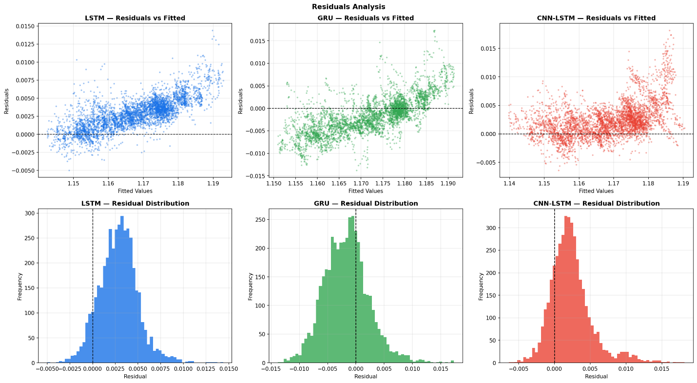
Figure 9: Residuals analysis — scatter of residuals vs fitted values (top) and residual distribution histograms (bottom) for LSTM, GRU, and CNN-LSTM

Discussion
Our results provide tentative confirmation that LSTM-based networks perform well in short-term forex prediction. The superior RMSE and R² of LSTM is probably due to its capacity to maintain regime-relevant information across the 48-step look-back window; the gating mechanism allows it to selectively keep information about the current regime (trending up or down) even in the presence of noise which would otherwise mask it.
The CNN-LSTM's better MAE and MAPE with a slightly inferior RMSE is noteworthy. If we interpret this as a trading system, the MAPE (0.2344%) is equivalent to a mean absolute error of 2.7 pips (on a 1.17 quote). This is probably the most important metric: the mean prediction error is smaller for CNN-LSTM, though it may occasionally make larger errors (that add to RMSE). The convolutional layer seems to serve as a helpful filter removing high-frequency micro-variations and feeding smoother representations to the LSTM.
The relatively poor performance of GRU is surprising given that it usually performs on par with LSTM. It is possible that the time horizon (48 time steps, or 24 hours) makes the additional memory of LSTM's distinct cell state useful. The single hidden state of a GRU may not be as able to compact the long-term dependencies at this scale.
A weakness of all three models is the small positive bias seen in the residuals. This is a common characteristic of regression forecasters on trending data: the forecaster captures the mean behavior of the training distribution but is slow to lead at trend reversals. This could be further investigated by using direction-sensitive loss functions or ensemble techniques incorporating explicit regime switching.

Conclusion
In this research, we benchmarked three deep learning models for predicting the next-bar close price of EUR/USD M30 on a 27-month dataset, including 31 features. The LSTM achieved the best overall accuracy (RMSE = 0.00356, R² = 0.918), followed closely by CNNLSTM (RMSE = 0.00376, R² = 0.909), with GRU performing weakest (RMSE = 0.00431, R² = 0.880). Interestingly, CNN-LSTM demonstrated the lowest mean absolute and percentage errors, so it might be best suited for applications where mean accuracy of each prediction is more important than outlier handling.
The three models performed well with the early-stopping and learning-rate adaptation approach, usually converging within 20 epochs and with no significant overfitting. The combination of traditional technical indicators, candlestick patterns and time markers supplied enough information for R² values of greater than 0.88 in all model types - a significant achievement in the notoriously challenging task of short-term forex forecasting.
References
Dukascopy Bank SA (2024). Historical FOREX Data — EUR/USD M30 Bid OHLCV. Retrieved from Dukascopy Historical Data Export
Hochreiter, S. and Schmidhuber, J. (1997). Long Short-Term Memory. Neural Computation, 9(8), 1735–1780.
Cho, K., van Merrienboer, B., Gulcehre, C., Bahdanau, D., Bougares, F., Schwenk, H. and Bengio, Y. (2014). Learning Phrase Representations using RNN Encoder-Decoder for Statistical Machine Translation. arXiv:1406.1078.
Livieris, I.E., Pintelas, E. and Pintelas, P. (2020). A CNN-LSTM model for gold price timeseries forecasting. Neural Computing and Applications, 32, 17351–17360.
Sezer, O.B., Gudelek, M.U. and Ozbayoglu, A.M. (2020). Financial time series forecasting with deep learning: A systematic literature review. Applied Soft Computing, 90, 106181.

